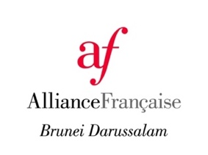
Alliance Française de Brunei Darussalam
No. 1, BH Garden, Simpang 116, Jalan Tungku
Phone: (+673) 829 1986
E-mail: contact@afbrunei.org
Website: www.afbrunei.org

MEMBERSHIP APPLICATION FORM

YOUR / YOUR COMPANY’S INFORMATION
Full name
Corporate / Institution
Position of representative
Contact No. | (Mobile) | (Office) |  | (Home)
Address
Email Address
Gender | Male Female |  | Nationality
Date of Birth |  |  | Identity Card No. / Passport No.

MEMBERSHIP CATEGORIES
Type | Yearly Fee | In case of a Family Membership, please mention the names of your spouse and children
Organisation | $90 | Name of Spouse
Family membership | $60 | Name of Child 1
Individual membership | $30 | Name of Child 2.

MODE OF PAYMENT
Cash
Cheque
(to “ALLIANCE FRANÇAISE DE BRUNEI »)
Direct deposit to our bank account
Account Name  Account Number  Swift/BIC | Alliance Française de Brunei  02-00-110-262560  BAIDBNBB

REMINDER
A copy of the “Policies” and “Rules & Regulations” are available at AFBD reception, and the “Policies” on our website.
By signing this form, you confirm that you have read and agree to these documents.
Membership is valid for one year with effect from the day of payment.
Fees once paid will not be refunded or transferred under any circumstances.

I, the undersigned, declare that all the information stated above is complete and accurate.

SIGNATURE | DATE

Disclaimer: We will not, in any circumstances, share your personal information with other individuals or organisations without your permission, including public organisations, corporations or individuals, except when applicable by law. We do not sell, communicate or divulge your information to any mailing lists.

For office use only
Receipt N° | …………………………………….
Receipt Date | …………………………………….
Validity Period | …………………………………….

